GSWS 2101: Gender Today
REPRODUCTIVE JUSTICE
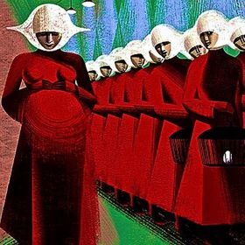
https://vignette.wikia.nocookie.net/the-handmaids-tale/images/a/a7/Handmaids_image.jpg/revision/latest?cb=20170214230919

FALL 2019 MONdays 12:30 to 3:20pm NWC CRN 35720

Instructor: Dr. Sally Mennill E-mail: mennills@douglascollege.ca

In this course we will explore ongoing struggles to define, medicalize, technologize, and/or constrain reproductive bodies. We will explore representations of reproductive bodies in North American political, social, and cultural contexts, and take an interdisciplinary and feminist approach to narratives, issues, practices, and arguments from preconception to end of life, including consideration of fictional and futuristic understandings of reproductive justice. Topics include contraception, abortion, fertility, non-normative kinship, childbirth, child rearing, menopause, and andropause. Assignments focus on popular and public discussions/debates in addition to scholarly ideas.

Prerequisites: GSWS 1100 OR GSWS 1101 or permission from the instructor (please email!)

Course Requirements: Textbooks:
Classroom engagement 20% 1) Reproductive Justice: An Introduction
Reading Response 20% by Loretta Ross and Rickie Solinger
Seminar Leadership 15% 2) The Handmaid’s Tale
Term Paper 25% by Margaret Atwood
Take-home Final 20%

